

|  |  |
| --- | --- |
|  |  |
|  |  |
|  |  |
|  |  |
|  |  |

|  |  |  |  |
| --- | --- | --- | --- |
|  |  |  |  |
|  |  |  |  |
|  |  |  |  |
|  |  |  |  |
|  |  |  |  |
|  |  |  |  |

# 

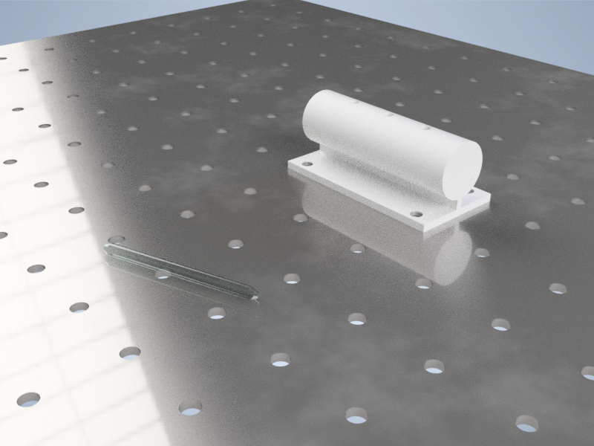

Figure 1. Artistic rendition of case study setup with glass rod and cylindrical bar to insert rod into.

# 

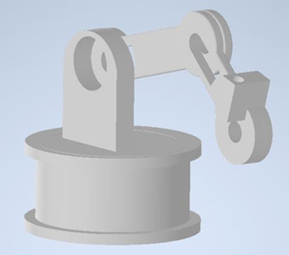

Figure 2. Initial CAD design.

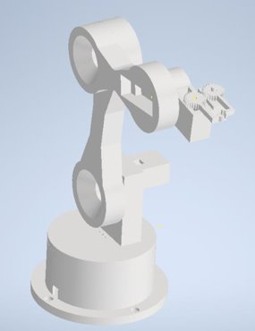

Figure 3. Updated CAD model, before servo gears and Base change (left), and after (right).

Figure 4. End connector servo gears.

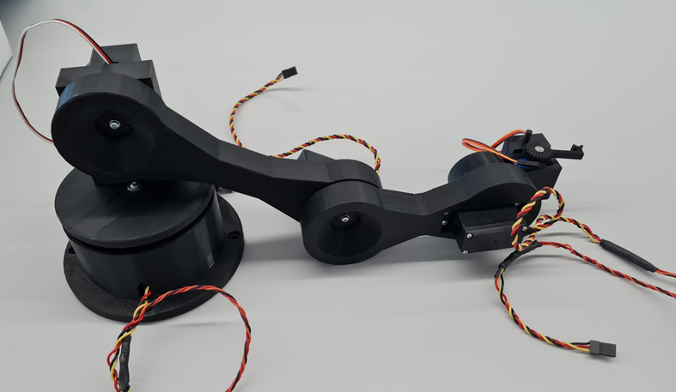

Figure 5. Full constructed assembly.

$$DOF=m\left(N-1-J\right)+ \sum_{i=1}^{J}{fi}$$

# 

## 

## 

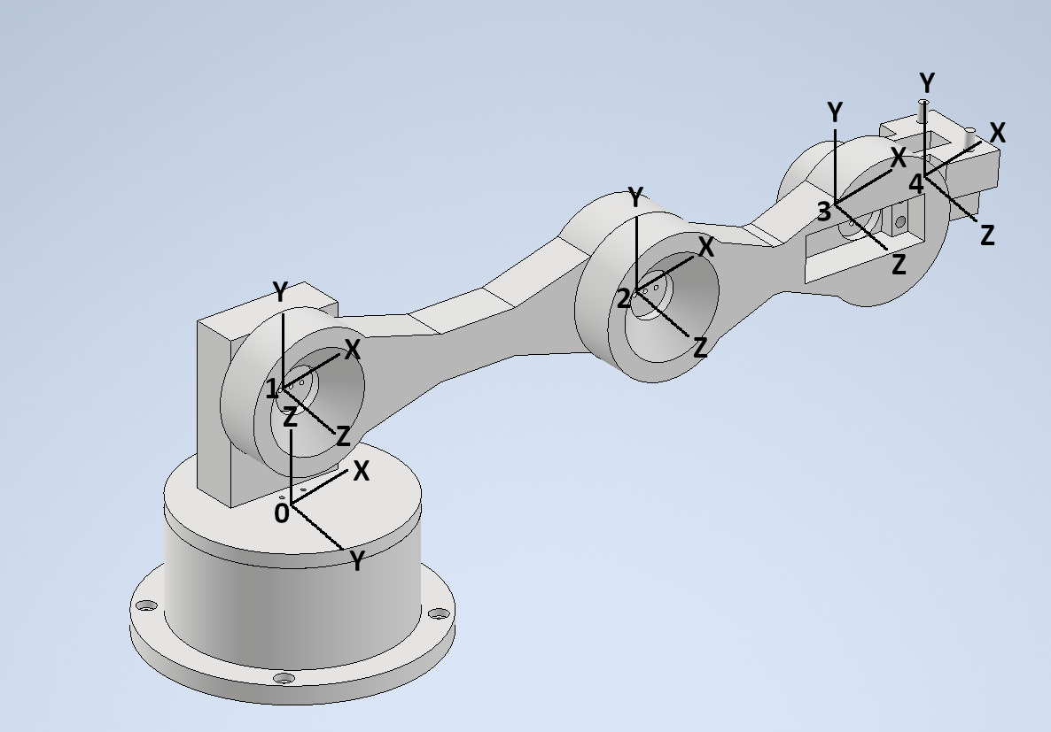

Figure 6. Robotic arm with local co-ordinate spaces defined for each joint for creation of the DH parameters.

|  |  |  |  |  |
| --- | --- | --- | --- | --- |
|  |  |  |  |  |
|  |  |  |  |  |
|  |  |  |  |  |
|  |  |  |  |  |
|  |  |  |  |  |

${}_{i}^{i-1}T={}_{R}^{i-1}T{}_{Q}^{R}T{}_{P}^{Q}T{}_{i}^{P}T$

$\left[\begin{aligned}0 \\ 90 \\ 47.5 \\ 0\end{aligned}\right]$ $\left[\begin{matrix}1 & 0 & 0 & 0 \\ 0 & 0 & -1 & 0 \\ 0 & 1 & 0 & 47.5 \\ 0 & 0 & 0 & 1\end{matrix}\right]$

$\left[\begin{aligned}151 \\ 0 \\ 0 \\ 0\end{aligned}\right]$ $\left[\begin{matrix}1 & 0 & 0 & 151 \\ 0 & 1 & 0 & 0 \\ 0 & 0 & 1 & 0 \\ 0 & 0 & 0 & 1\end{matrix}\right]$

$\left[\begin{aligned}100 \\ 0 \\ 0 \\ 0\end{aligned}\right]$ $\left[\begin{matrix}1 & 0 & 0 & 100 \\ 0 & 1 & 0 & 0 \\ 0 & 0 & 1 & 0 \\ 0 & 0 & 0 & 1\end{matrix}\right]$

$\left[\begin{aligned}55 \\ 0 \\ 0 \\ 0\end{aligned}\right]$ $\left[\begin{matrix}1 & 0 & 0 & 55 \\ 0 & 1 & 0 & 0 \\ 0 & 0 & 1 & 0 \\ 0 & 0 & 0 & 1\end{matrix}\right]$

$$\left[\begin{matrix}1 & 0 & 0 & 306 \\ 0 & 0 & -1 & 0 \\ 0 & 1 & 0 & 47.5 \\ 0 & 0 & 0 & 1\end{matrix}\right]$$

## 

## 

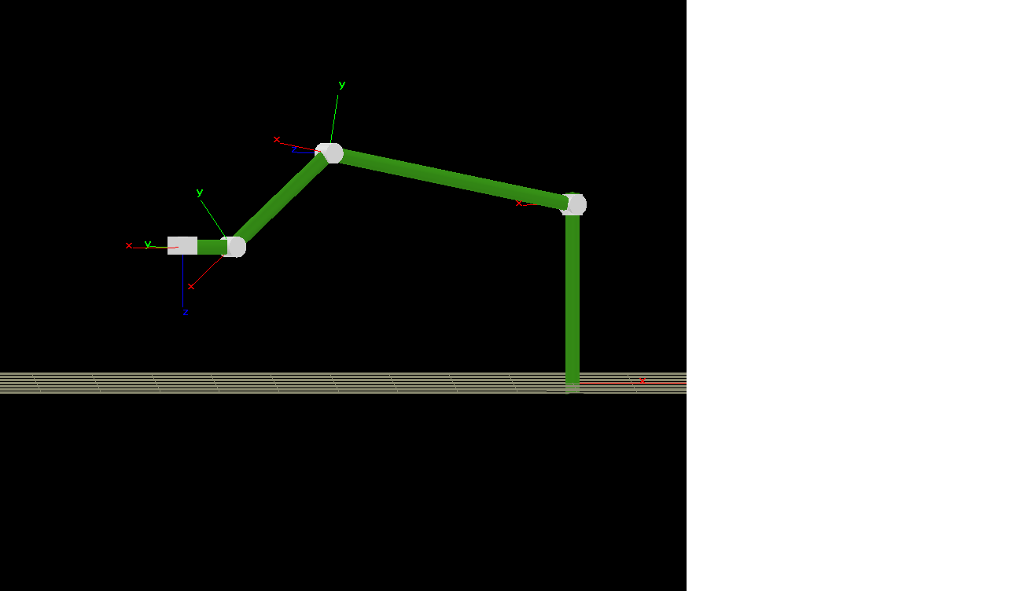

Figure 7. Kinematic model of robotic arm visualized.

## 

Figure 8: Kinematic schematic, example 1 orientation.

$q_{1}$

$$\boxed{q_{1}=atan⁡\left(\frac{y}{x}\right)= atan2\left(y,x\right)}$$

$$\boxed{r=\sqrt{x^{2}+y²}}$$

$q_{4}$ $φ$ $φ=q_{2}+q_{3}+q_{4}$ $φ$ $l_{3}$ $r_{3}, z_{3}$

$$\boxed{r_{3}=r-l_{3}cos⁡(φ)}$$

$$\boxed{z_{3}=z-l_{3}sin⁡(φ)}$$

$$\boxed{z_{3}=z-l_{3}sin⁡(φ)}$$

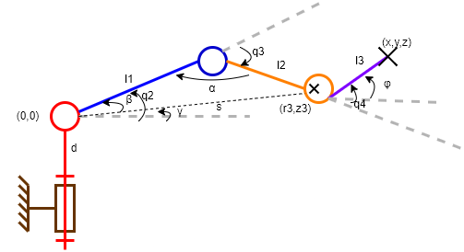 $l_{1}$ $l_{2}$ ${α=-q}_{3}+π$ $r, z$ $q_{2}$ $r_{3}, z_{3}$

Figure 9. Kinematic schematic, example 2 orientation.

$$s_{3}^{2}=r_{3}^{2}+z_{3}^{2}=l_{1}²+l_{2}²-2l_{1}l_{2}cos⁡(α)$$

$$-cos\left(α\right)=\frac{r_{3}^{2}+z_{3}^{2}-{(l}_{1}²+l_{2}²)}{2l_{1}l_{2}}$$

$$-cos\left(α\right)=\frac{r_{3}^{2}+z_{3}^{2}-{(l}_{1}²+l_{2}²)}{2l_{1}l_{2}}$$

$${α=-q}_{3}+π$$

$${\cos\left(α\right)=cos⁡(-q}_{3}+π)=cos(q_{3})$$

$${\cos\left(α\right)=cos⁡(-q}_{3}+π)=cos(q_{3})$$

$$-cos\left(q_{3}\right)=\frac{r_{3}^{2}+z_{3}^{2}-{(l}_{1}²+l_{2}²)}{2l_{1}l_{2}}$$

$$\boxed{q_{3}=-arcos\left(\frac{r_{3}^{2}+z_{3}^{2}-{(l}_{1}²+l_{2}²)}{2l_{1}l_{2}}\right)}$$

$l_{1}$ $q_{1}$ $q_{2}=γ+β$

$$γ=atan\left(\frac{z_{3}}{r_{3}}\right)$$

$$β= atan\left(\frac{l_{2}\sin{(q_{3})}}{l_{1}+l_{2}\cos{{(q}_{3})}}\right)$$

$$\boxed{q_{2}=atan\left(\frac{z_{3}}{r_{3}}\right)+atan\left(\frac{l_{2}\sin{(q_{3})}}{l_{1}+l_{2}\cos{{(q}_{3})}}\right) }$$

$q_{2}$ $q_{3}$ $q_{4}$ $φ$

$$φ=q_{2}+q_{3}+q_{4}$$

$$\boxed{q_{4}=φ-(q_{2}+q_{3})}$$

$$\boxed{q_{4}=φ-(q_{2}+q_{3})}$$

$$r=\sqrt{x^{2}+y²}$$

$$r_{3}=r-l_{3}cos⁡(φ)$$

$$z_{3}=z-l_{3}sin⁡(φ)$$

$$q_{1}=atan⁡\left(\frac{y}{x}\right)= atan2\left(y,x\right)$$

$$q_{3}= -arcos\left(\frac{{r_{3}}^{2}+{z_{3}}^{2}-({l_{1}}^{2}+{l_{2}}^{2})}{2l_{1}l_{2}}\right)$$

$$q_{2}=\operatorname{atan}\left(\frac{z_{3}}{r_{3}}\right)+atan\left(\frac{l_{2}sin(q_{3})}{{l_{1}+l}_{2}cos(q_{3})} \right)= \operatorname{atan}{2\left(z_{3}, r_{3}\right)}+atan2\left(l_{2}sin(q_{3}), {l_{1}+l}_{2}cos(q_{3}) \right)$$

$$q_{4}=φ-(q_{2}+q_{3})$$

$$q_{2}=\operatorname{atan}\left(\frac{z_{3}}{r_{3}}\right)+atan\left(\frac{l_{2}sin(q_{3})}{{l_{1}+l}_{2}cos(q_{3})} \right)= \operatorname{atan}{2\left(z_{3}, r_{3}\right)}+atan2\left(l_{2}sin(q_{3}), {l_{1}+l}_{2}cos(q_{3}) \right)$$

$$q_{4}=φ-(q_{2}+q_{3})$$

## 

Figure 10. Weights (W*) of each arm component imparting Moments (M*) on joints.

|  |  |  |  |  |  |  |
| --- | --- | --- | --- | --- | --- | --- |
|  |  | |  | |  | |
|  |  |  |  |  |  |
|  |  |  |  |  |  |  |
|  |  |  |  |  |  |  |
|  |  |  |  |  |  |  |
|  |  |  |  |  |  |  |
|  |  |  |  |  |  |  |
|  |  |  |  |  |  |  |

|  |  |
| --- | --- |
|  |  |
|  |  |
|  |  |
|  |  |
|  |  |
|  |  |
|  |  |

|  |  |  |  |
| --- | --- | --- | --- |
|  |  | | |
|  |  |  |
|  |  |  |  |
|  |  |  |  |
|  |  |  |  |

## 

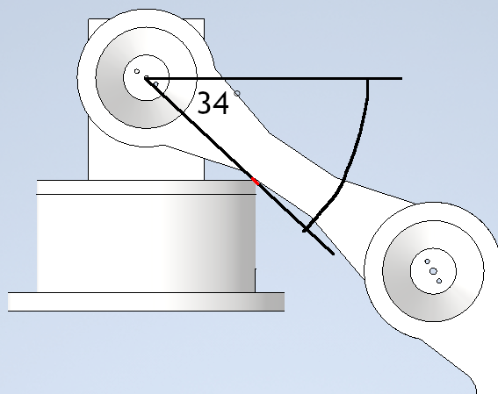

Figure 11. Maximum rotation possible of Joint 2 as it would otherwise collide with the base (point of contact highlighted in red).

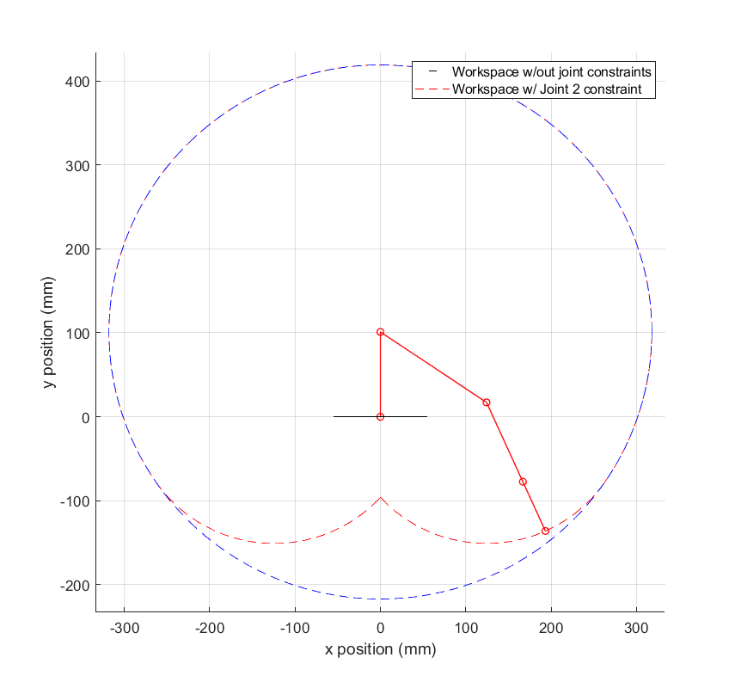

Figure 12. Workspace of the robotic arm with example of arm configuration. Links shown in solid red lines, joints are small red circle markers. Workspaces shown for arm with no joint constraints (blue) and with expected Joint 2 constraint (red).

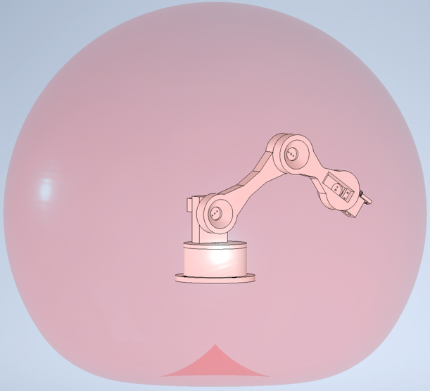

Figure 13. 3D workspace of the robotic arm. Note that instead of a sphere, the bottom of the workspace is rounded inwards due to the first arm joint constraint.

# 

## 

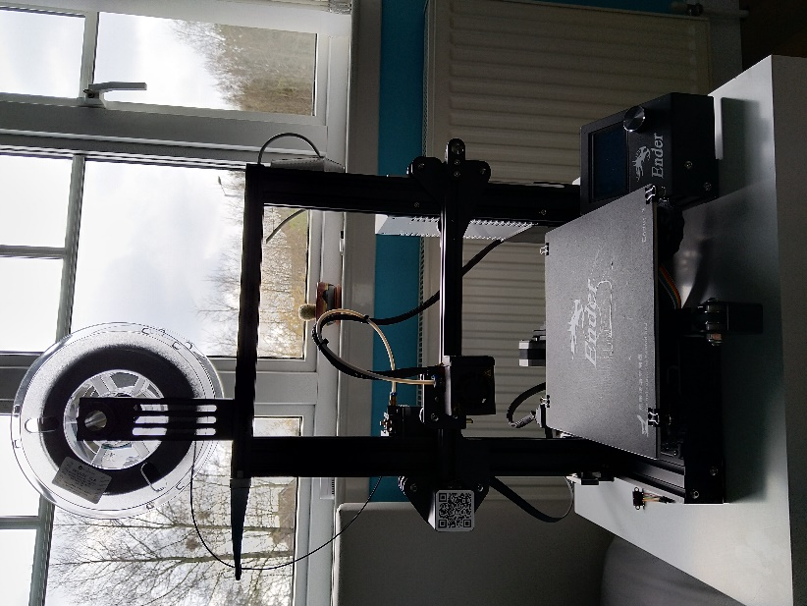

Figure 14. 3D printing rig used for fabrication.

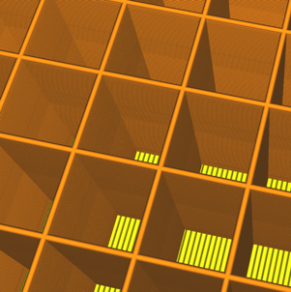

Figure 16. Cubic infill pattern used for fabricating the non-gripper parts, strong in all directions.



Figure 16. Cubic infill pattern used for fabricating the non-gripper parts, strong in all directions.

## 

|  |  |  |  |
| --- | --- | --- | --- |
|  |  |  |  |
|  |  |  |  |
|  |  |  |  |
|  |  |  |  |
|  |  |  |  |
|  |  |  |  |
|  |  |  |  |
|  |  |  |  |
|  |  |  |  |

# 

## 

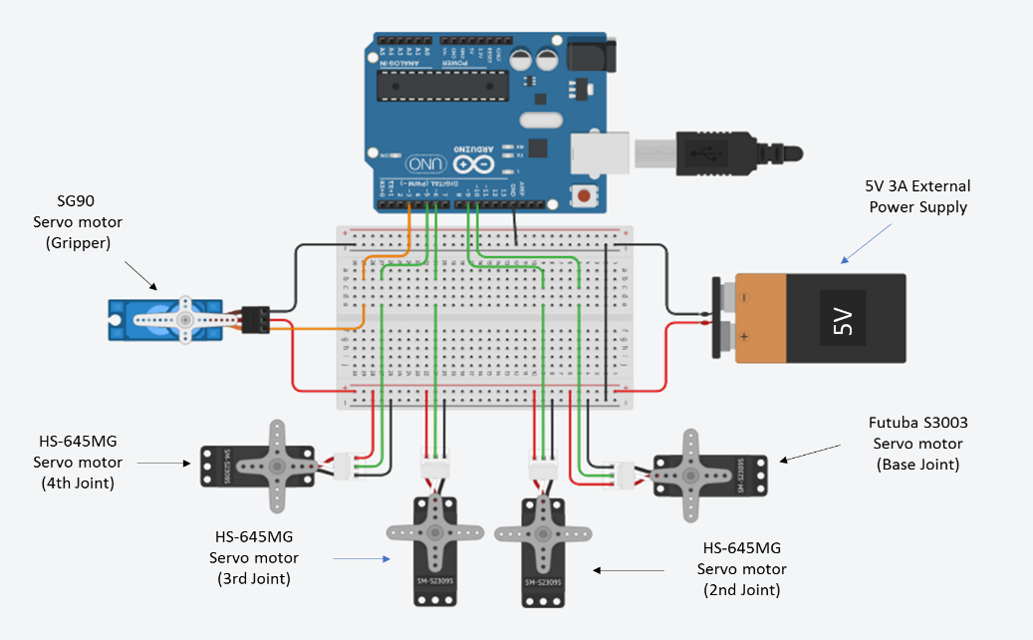

Figure 17. Circuit diagram of electronics used in the robotic arm.

$q_{1}$ $q_{2}$ $q_{3}$ $q_{4}$

## 

# 

## 

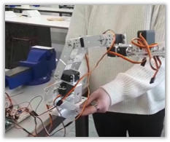

Figure 18. Store purchased robot arm used to test code.

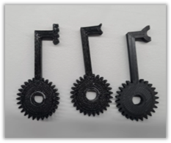

Figure 19. Various types of gripper tested. Final gripper highlighted in red.

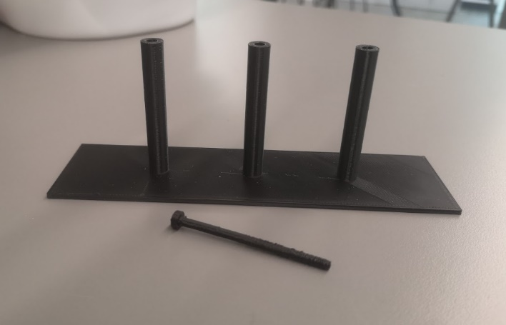

Figure 20. Testing apparatus with pin and pin holders.

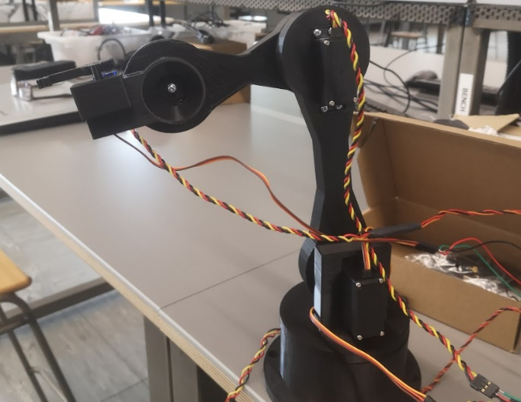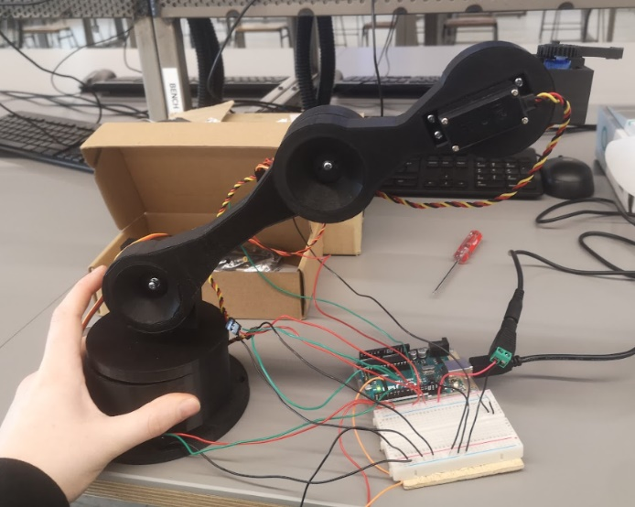

Figure 21. Robotic arm assembled in 2 different orientations.

## 

## 

# 

## 

|  |  |
| --- | --- |
|  |  |
|  |  |
|  |  |
|  |  |
|  |  |

|  |  |
| --- | --- |
|  |  |
|  |  |
|  |  |
|  |  |
|  |  |

|  |  |
| --- | --- |
|  |  |
|  |  |
|  |  |
|  |  |
|  |  |

|  |  |
| --- | --- |
|  |  |
|  |  |
|  |  |
|  |  |
|  |  |

|  |  |
| --- | --- |
|  |  |
|  |  |
|  |  |
|  |  |
|  |  |

## 

